06 January 2026
Name: AISHA MUKHTAR | Age: AD | Sex: F | Ref No:0002
Clinical Details: USG Pelvic |  |  | US:02
OBSTETRIC ULTRASOUND
UTERUS: The uterus is gravid and shows multifetal intrauterine pregnancy. The amniotic fluid is adequate. Thick inter twin membrane seen (suggestive of MCDA twin pregnancy).

Twin 1:
PRESENTATION = BREECH
PLACENTA = ANTERIOR
GA = 33 weeks 02 day(s)
EDD = 24/02/2026(±2weeks)
EFW = 2.08Kg
GENDER = N0T SEEN

Twin 2:
PRESENTATION = BREECH
PLACENTA = ANTERIOR
GA = 32 weeks 3 day(s)
EDD = 03/03/2026 (±2weeks)
EFW = 1.91Kg
GENDER = N/S (NOT SEEN)
CONCLUSION: Twin MCDA gestation AT 32 weeks 03 day(s).

NB: There is mild probe tenderness at the epigastric region which is suggestive of PUD
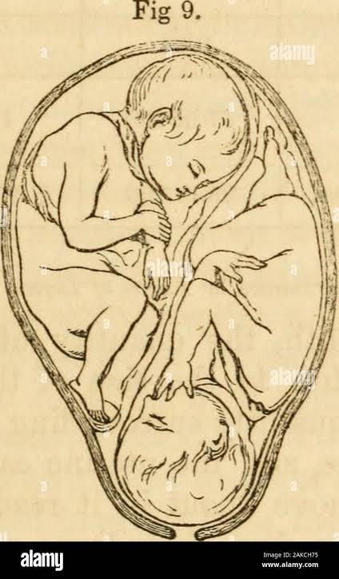

```Ultrasound Specialist

